7COM1079-0901-2025 - Team Research and Development Project

Final report title: Gender Differences in Billionaire Net Worth: A Statistical Analysis.

Group ID: A 201
Dataset number: DS242
Prepared by: Venkata Sai Santhosh Sreekar Anumala - 24176754
Azeemoddin Mohammad - 2302841
Ponnala Tarun Chary - 24180752
Siyab Padinhar Mohammed - 17058231

University of Hertfordshire
Hatfield, 2025
Table of Contents
1. Introduction 2
1.1 Problem statement and research motivation 2
1.2 The dataset 2
1.3 Research question 2
1.4 Null hypothesis and alternative hypothesis 2
2. Background research 3
2.1 Research papers 3
2.2 Why the RQ is of interest 3
3. Visualisation 4
3.1 Appropriate graphs 4
3.2 Additional information for understanding 5
3.3 Useful information for data understanding 5
4. Analysis 6
4.1 Statistical test used and output 6
4.2 Hypothesis decision 6
5. Evaluation - group experience 7
5.1 What went well 7
5.2 Points for improvement 7
5.3 Group time management 7
5.4 Project’s overall judgement 7
5.5 Comment on GitHub log output 7
6. Conclusions 8
6.1 Results explained 8
6.2 Interpretation of results 8
6.3 Future work and limitations 8
References 9
Appendix A 10
Appendix B 13

1. Introduction

1.1 Problem statement and research motivation
The difference in the world has become a significant area of research and it has a great impact in defining the global economy. Moreover, wealth generates social influence and political power to shape social and cultural norms (Keister, Lee and Yavorsky, 2021). The gender disparities in wealth accumulation and asset ownership are prevalent among the populations (Ischinsky and Tisch, 2023). However, the number of the studies exploring gender difference among billionaires is very insignificant. This is the reason why statistical testing is required to ascertain whether there is a difference between the average net worth of male and female billionaires.

1.2 The dataset
The dataset utilised in this research is the Billionaires Statistics Dataset on Kaggle. It holds the demographic and financial data of more than 2600 billionaires in the world. In this analysis, the two variables were considered, gender and finalWorth. Once all entries were filtered by the missing values, the resultant sample size was 2640 people: 337 female, 2303 male. The variable of gender was transformed into a factor variable to facilitate the right visualisation and statistical testing.

1.3 Research question
Is there a difference in the mean net worth between male and female billionaires?
This question aims to identify whether gender plays a measurable role in the average financial status of individuals in the highest income category.

1.4 Null hypothesis and alternative hypothesis
To answer the research question, the following hypotheses were developed:
H0: There is no difference in the mean net worth of male and female billionaires.
H1: There is a difference in the mean net worth of male and female billionaires.
These hypotheses allow the use of inferential statistics to determine whether any observed differences in sample means are statistically significant. A two-sample test is required because the groups are independent. The test is two-sided since there is no assumption about which gender might have the higher mean net worth.

2. Background research

2.1 Research papers
The issue of inequality in wealth as applied to gender is well-documented in most countries.
As per Keister, Lee and Yavorsky (2021), discovered that women generally have less wealth than men because of the discrepancies between earnings, career advancement, and financial access. Their study focuses on structural obstacles, which women cannot overcome over time in developing long-term assets.
According to Rezaul et al. (2024), delved into concentration of wealth amongst the ultra-rich and pointed out how the male billionaires control the sectors like technology, financial and manufacturing. It was also observed that the female billionaires tend to inherit their wealth more and the male billionaires tend to gain wealth due to entrepreneurship. It implies that gender differences in wealth of billionaires might be affected by industry trends.
In addition Yavorsky, Keister and Qian (2020), conducted another study that was relevant, which compared the wealth distributions in the US and discovered that gender gaps increase as higher percentiles are used. Even though they are not working specifically on the topic of billionaires, their work helps to promote the notion that gender contributes to the pattern of ownership of assets. All these studies demonstrate that gender disparity in wealth is widespread and enduring.

2.2 Why the RQ is of interest
The research question serves to matter since the economic, social and political structures are influenced by the accumulation of wealth by billionaires. Although there has been increased research on gender inequality, the analysis of the statistical data on billionaires in particular is scarce. In addition, gender disparity in billionaires brings up the issues of opportunity, industry representation, and resource access. The insight into the possibility of any meaningful differences in the mean net worth can inform further research on the dynamics of the industry, the creation of wealth, and how gender affects the economic performance. This study thus bridges the gap and helps in future research on inequality studies.

3. Visualisation

3.1 Appropriate graphs
# Plotting Boxplot of Networth by Gender
ggplot(billionaires_clean, aes(x = gender, y = finalWorth)) +
geom_boxplot() +
labs(title = "Net Worth of Billionaires by Gender",
x = "Gender",
y = "Net Worth (USD Millions)") + theme_minimal()
Male billionaires generally have a higher median net worth compared to the female billionaires.
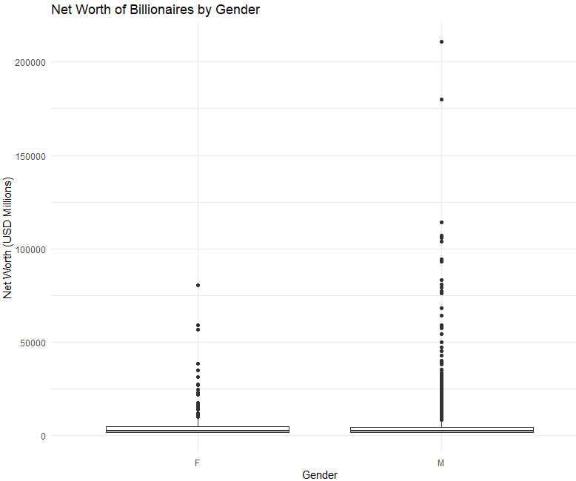
Figure 1: Boxplot

3.2 Additional information for understanding
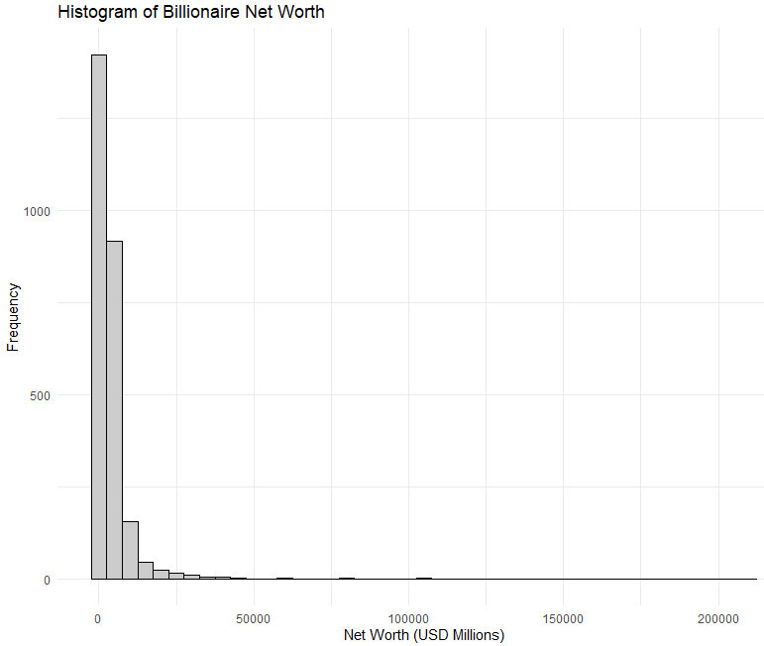
Figure 2: Histogram
The histogram displays a highly right-skewed distribution of billionaire net worths. The overwhelming majority of billionaires possess a net worth in the lower ranges (under $20 billion), while a very small number are extreme outliers with significantly higher net worths. This pattern highlights significant global wealth inequality.

3.3 Useful information for data understanding
The visualisations indicate that whereas the range of the billionaire net worth is tremendously large, male and female groups distributions appear to resemble each other. There are skewness and extreme outliers in both groups. The fact that there are many similarities in the forms indicates that any variation in the means can be slight and this is where the need to carry out a statistical test arises.

4. Analysis

4.1 Statistical test used and output
A Welch two-sample t-test was selected because the male and female groups differ greatly in size and variance. Summary statistics show:
Females: n = 337, mean = 4570, SD = 2612
Males: n = 2303, mean = 4632, SD = 10120
The t-test returned:
t = −0.13173, df = 527.11, p = 0.8952
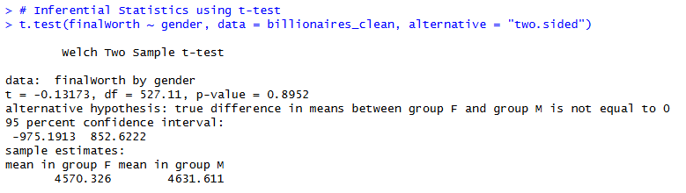
Figure 3: Test Output
The 95% confidence interval for the difference was −975.19 to 852.68. Cohen’s d was −0.006, indicating a negligible effect size.
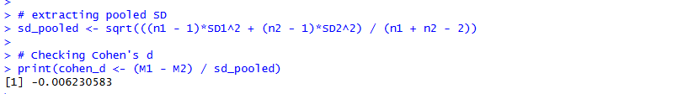
Figure 4: Cohen's d Output

4.2 Hypothesis decision
Using the p-value of 0.8952 is much larger than the level of significance of 0.05, the null hypothesis is not rejected. This implies that the statistically significant difference in the mean of the net worth between male and female billionaires is not present. This conclusion is supported by the fact that the confidence interval is zero. The effect size (Cohen’s d = -0.006) is extremely small, which means that the difference between the groups is insignificant in practice. The findings in general indicate that there is no correlation between gender and mean billionaire net worth in this data.

5. Evaluation - group experience

5.1 What went well
The project was effective both in the teamwork and technical implementation. The group also worked well and divided roles on cleaning data, analysis and writing reports. R enabled the dataset to be handled and processed efficiently and generated visualisations with ease. The members of the group helped one another to learn statistical concepts and interpretate the results and this enhanced the final output.

5.2 Points for improvement
The main challenge was to interpret skewed information because billionaire wealth is extreme. Next projects may invest more time on alternative statistical procedures or data transformation. Another way that the group might practice better documentation is to simplify code following.

5.3 Group time management
Management of time was enhanced as the project went on. The first delays have been resolved through scheduling of meetings and clear separation of tasks. Adjustment of the workflow led to meeting deadlines successfully. Proper planning initially would prevent an initial setback.

5.4 Project’s overall judgement
In general, the project was a skillful one, and it was an experience in statistical analysis, data visualisation, and working in a team. The team became confident about working with R and reading results. The conclusions were understandable and significant, which helped in the realization of gender trends among billionaires.

5.5 Comment on GitHub log output
In Appendix B, it is shown in GitHub log. Three meaningful commits are evidence of cleaning up the dataset, the use of statistical tests, and better visualisational enhancement. These commits indicate gradual project development and trace the role of every stage in the final analysis.

6. Conclusions

6.1 Results explained
It was analysed that there is a minimal difference in the mean net worth of male and female billionaires. The t-test did not identify the statistically significant difference, and the effect size was approximately zero. Though male billionaires are more varied in terms of net worth, the central tendency is almost identical between the genders. There is no significant difference evidenced in general.

6.2 Interpretation of results
The results indicate that in the billionaire group, the gender does not play a role in the average monetary position. Men are the ones who dominate the world, but both male and female billionaires become equal in wealth. This could be the trends in the industry, the family system of inheriting, or some exceptional features of the ultra-rich population. The knowledge of these trends assists in putting the larger discussions of inequality into perspective.

6.3 Future work and limitations
The shortcomings are the lack of equal sample size, biased data, and the absence of such variables as industry, age, source of wealth. Later studies might apply regression models or compare subsets of billionaires to investigate the factors that lead to difference in wealth other than gender.

References
Ischinsky , E.I. and Tisch, D.T. (2023). Women in the Global Super Rich. An Analysis of the Forbes World’s Billionaires List, 2010–2023. Australian Feminist Studies. [online] doi:https://doi.org/10.1080//08164649.2023.2243649.
Keister, L.A., Lee, H.Y. and Yavorsky, J.E. (2021). Gender and Wealth in the Super Rich: Asset Differences in Top Wealth Households in the United States, 1989–2019. Sociologia, [online] 15(2), pp.25–55. doi:https://doi.org/10.6092/issn.1971-8853/12394.
Rezaul, K.M., Khan, M.U., David, N.W., Kazy, Tajnuva Jannat and Islam, M.S. (2024). Exploring Wealth Dynamics: A Comprehensive Big Data Analysis of Wealth Accumulation Patterns. International Journal of Advanced Computer Science and Applications, [online] 15(12). doi:https://doi.org/10.14569/ijacsa.2024.0151206.
Yavorsky, J.E., Keister, L.A. and Qian, Y. (2020). Gender in the One Percent. Contexts, [online] 19(1), pp.12–17. doi:https://doi.org/10.1177/1536504220902196.

Appendix A
# loading required package
if (!require(tidyverse)) install.packages("tidyverse")
library(tidyverse)

# loading dataset
billionaires <- read.csv("Billionaires Statistics Dataset.csv")

# displaying Columns names
colnames(billionaires)

# inspecting structure
str(billionaires)

# missing values summary
colSums(is.na(billionaires))

# keeping only required columns and removing missing values
billionaires_clean <- billionaires %>% select(gender, finalWorth) %>%
filter(!is.na(gender), !is.na(finalWorth))

# converting gender to factor
billionaires_clean$gender <- factor(billionaires_clean$gender)

# checking sample sizes
table(billionaires_clean$gender)

# verifying clean data
summary(is.na(billionaires_clean))

# Statistical summary by gender
billionaires_clean %>% group_by(gender) %>% summarise(n = n(), mean_worth = mean(finalWorth),
sd_worth = sd(finalWorth), median_worth = median(finalWorth))

# Plotting Histogram of Billionaire net worth
ggplot(billionaires_clean, aes(x = finalWorth)) +
geom_histogram(binwidth = 5000, fill = "grey80", colour = "black") +
labs(title = "Histogram of Billionaire Net Worth",
x = "Net Worth (USD Millions)",
y = "Frequency") + theme_minimal()

# Plotting Boxplot of Networth by Gender
ggplot(billionaires_clean, aes(x = gender, y = finalWorth)) +
geom_boxplot() +
labs(title = "Net Worth of Billionaires by Gender",
x = "Gender",
y = "Net Worth (USD Millions)") + theme_minimal()

# Inferential Statistics using t-test
t.test(finalWorth ~ gender, data = billionaires_clean, alternative = "two.sided")

# computing group statistics
billionaires_clean %>% group_by(gender) %>% summarise(
n = n(), mean = mean(finalWorth), sd = sd(finalWorth))

# storing t-test result
t_test_result <- t.test(finalWorth ~ gender, data = billionaires_clean, alternative = "two.sided")

# extracting values
M1 <- stats$mean[1]
M2 <- stats$mean[2]
SD1 <- stats$sd[1]
SD2 <- stats$sd[2]
n1 <- stats$n[1]
n2 <- stats$n[2]

# extracting pooled SD
sd_pooled <- sqrt(((n1 - 1)*SD1^2 + (n2 - 1)*SD2^2) / (n1 + n2 - 2))

# Checking Cohen's d
print(cohen_d <- (M1 - M2) / sd_pooled)

# Checking t-test results for Hypothesis testing
if (t_test_result$p.value < 0.05) {
cat("Null hypothesis rejected: there is a significant difference in mean net worth by gender.\n")
} else {
cat("Null hypothesis not rejected: no significant difference in mean net worth by gender.\n")
}

Appendix B

